

Computer Networks (ENCS3320)

Project Report

Project #2

Prepared by:

Christina Saba ID: #1201255

Jenin Mansour ID: #1200540

Pierre Backleh ID: #1201296

Instructor’s Name: Dr. Abdalkarim Awad

Section: 2

Date: 4 July 2023

Table of Contents

Part 1.1 3

Explain briefly the functions: 3

DHCP: 3

DNS: 3

ICMP: 3

Part 1.2 4

Using wireshark software, sniff DHCP, DNS, and ICMP packets 4

DHCP 4

DNS 5

ICMP 6

Part 2 7

Using packet tracer, build a network that contains **at least** 4 routers –do **not** use ring topology- 2 switches, 5 PCs. 7

Subnetting 8

Using ping command to show reachability from one host to another host. 9

Use tracert command to show the path a packet traversed to reach its destination from each subnet host to a remote destination. 11

Use dns server and web server 13

# Part 1.1

## Explain briefly the functions:

### DHCP:

(Dynamic Host Configuration protocol) used to automatically assign IP addresses and network configuration settings to devices within a network. and it provide other imprortant parameters sch that DNS,GateWay, and SubnetMask.

### DNS:

(Domain Name System) used to translate domain names into IP addresses, also provides other services, such as email routing and directory services, making it a critical component of the internet infrastructure, hostname to IP address translation , host aliasing, mail server aliasing, and load distribution.

### ICMP:

(Internet Control Message Protocol ) used is to determine if the data is getting to its destination at the right time. When a device is unreachable, ICMP can be used to send an "Echo Request" (ping) message and receive an "Echo Reply" to verify if the device is reachable. ICMP plays a vital role in network troubleshooting and network management tasks.

# Part 1.2

## Using wireshark software, sniff DHCP, DNS, and ICMP packets

* show the series of packets for each service that complete the request and service response, choose one packet from each service and explain at least 5 fields.

### DHCP

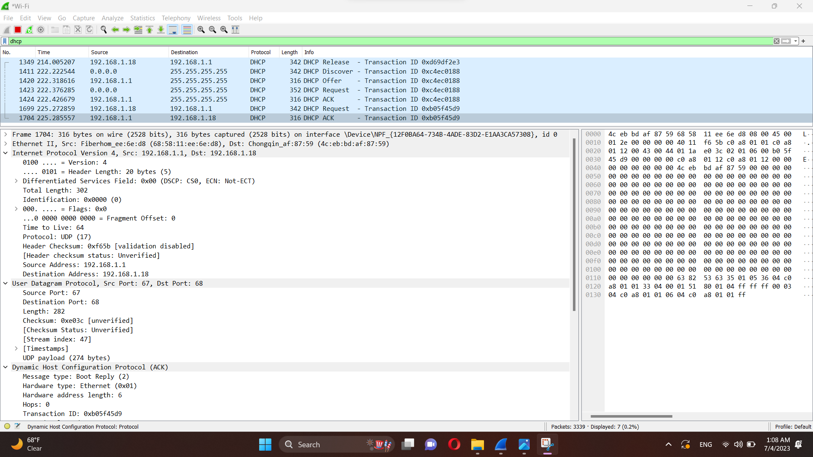

1. Version: the internet protocol has a version of IPv4
2. Header length: the total length of the header is 20 bytes
3. Time to live TTL: the packet has the ability to travel through 128 routers
4. Source Address: the local IP address = 192.168.1.1
5. Destination address: the destination has IP = 192.168.1.18 (requsted IP)
6. Source port: the source port has a value of 67
7. DHCP (ack) msg DHCP server sends address

### DNS

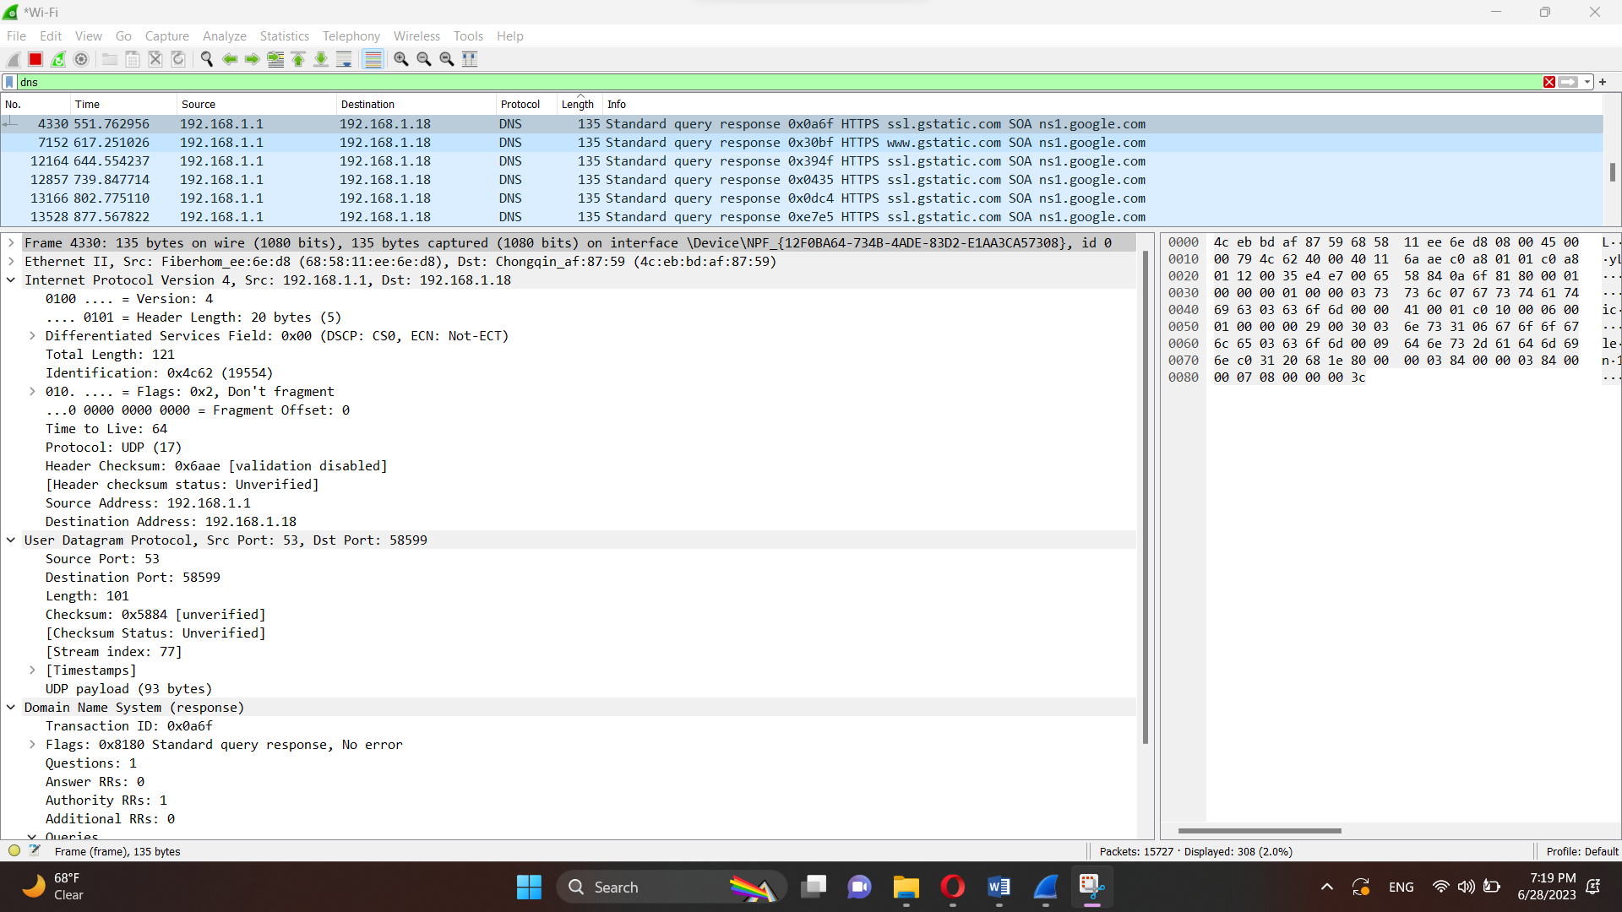

1. Version: the internet protocol has a version of IPv4
2. Total length of the packets is 121 bits
3. Time to live TTL: the router has the ability to travel through 64 routers
4. Source Address: the local IP address = 192.168.1.1
5. Destination address: the destination has IP = 192.168.1.18
6. Protocol: the network is based on UDP connection
7. (response ): It is a response to a DNS query sent from the source (192.168.1.1) to the destination (192.168.1.18) on UDP port 53.

### ICMP

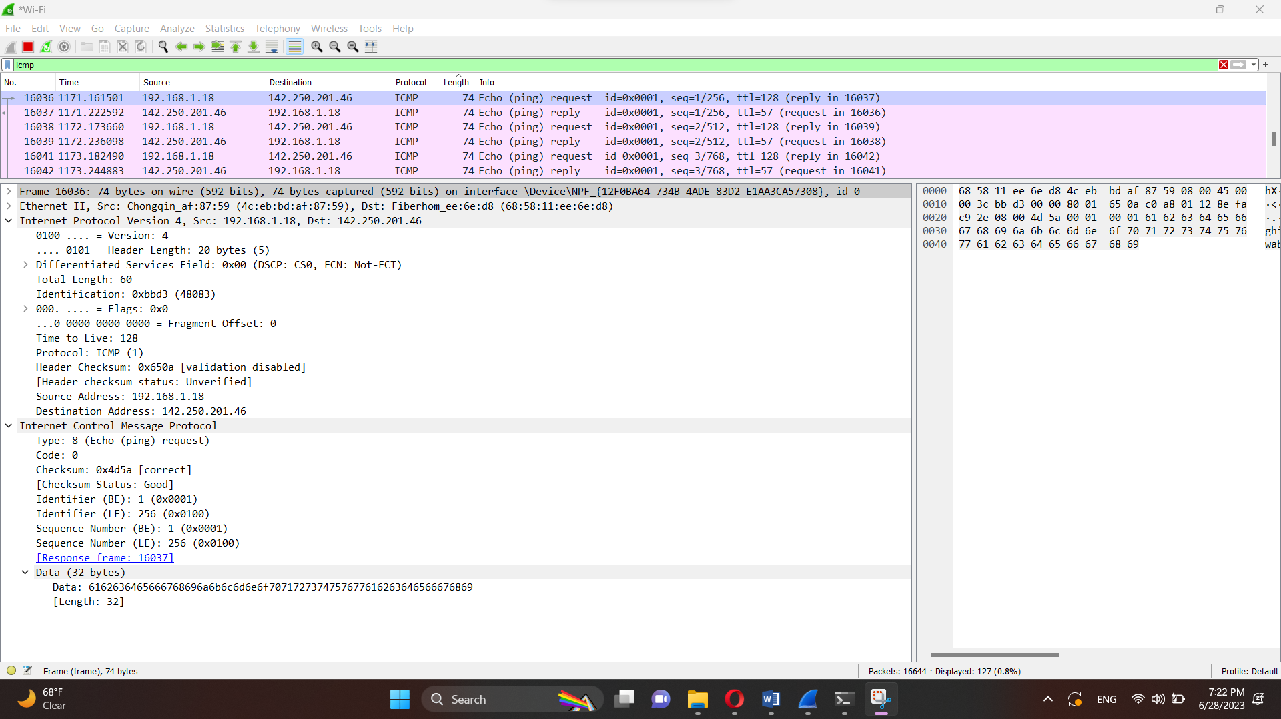

We wrote in CMD the following command: ping www.youtube.com, to obtain the previous packets.

1. Version: the internet protocol has a version of IPv4
2. Header length: the total length of the header is 20 bytes
3. Time to live TTL: the packet has the ability to travel through 128 routers
4. Source Address: the local IP address of our PC = 192.168.1.18
5. Destination address: the destination has IP = 142.250.201.46 is youtube address
6. Checksum: 0x4d53[correct] means that the packets are received without any error

# Part 2

## Using packet tracer, build a network that contains **at least** 4 routers –do **not** use ring topology- 2 switches, 5 PCs.

* Use **OSPF** routing protocol.
* At least in one subnet uses **DHCP**.
* The network should contain a **webserver**
* The network should contain a **DNS server**
* Build the IP addresses using your university **ID**
* If the ID is 1201234=120xyzw then the **IP** should be 205.x.y.0/24
* Using ping command to show reachability from one host to another host.
* Use tracert command to show the path a packet traversed to reach its destination from each subnet host to a remote destination.

Since we used 4 router, 2 switches, and 5 PCs, the total subnets were 5, so the ip addresses were calculated accordingly.

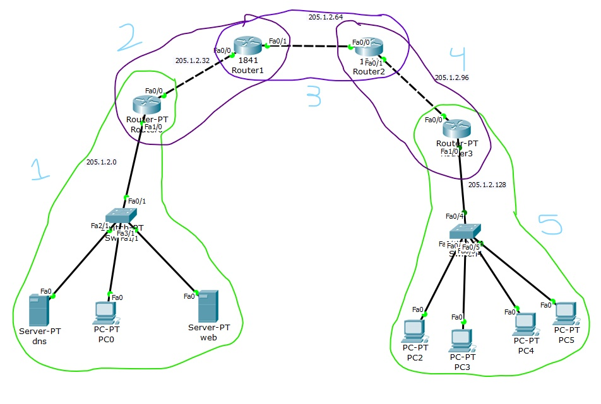

According to our assumption in choosing the IP address, the type of class is class C which has 8 bits for Subnet part. From the picture above, we need 5 subnets which means 3 bits are required 🡪 2^3

### Subnetting

* Subnet Mask: 205.1.2.11100000 🡪 255.255.255.224
* 1st subnet: 205.1.2.00000000 🡪 205.1.2.0/27
* 2nd subnet: 205.1.2.00100000 🡪 205.1.2.32
* 3rd subnet: 205.1.2.01000000 🡪 205.1.2.64
* 4th subnet: 205.1.2.01100000 🡪 205.1.2.96
* 5th subnet: 205.1.2.10000000 🡪 205.1.2.128

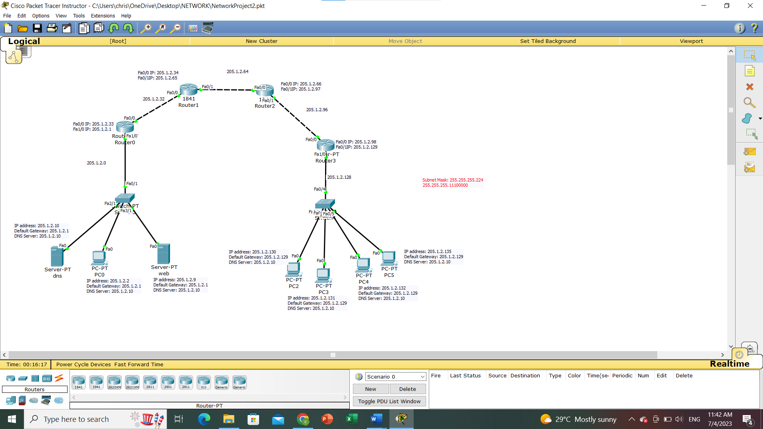

### Using ping command to show reachability from one host to another host.

The figure below shows ping PC5 to PC0 used in the command prompt in different subnets

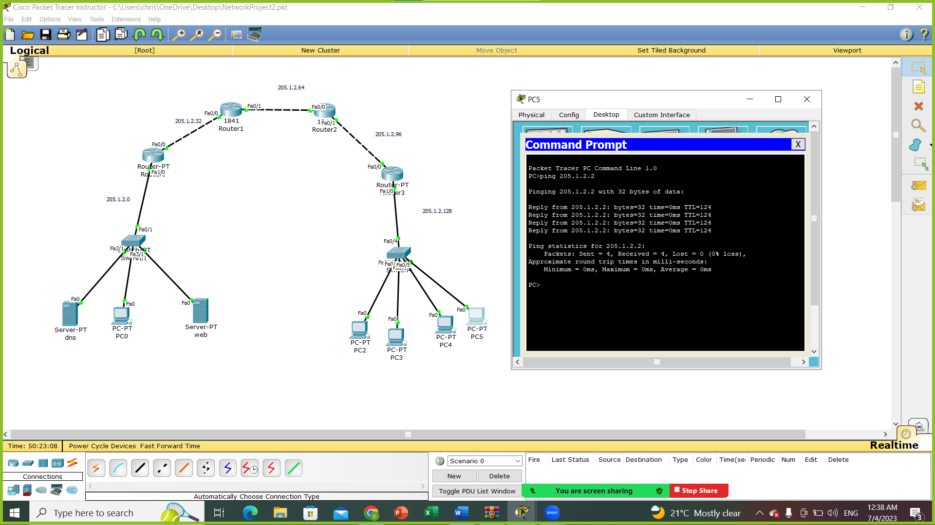

The figure below shows ping PC3 to PC5 used in the command prompt in the same subnet

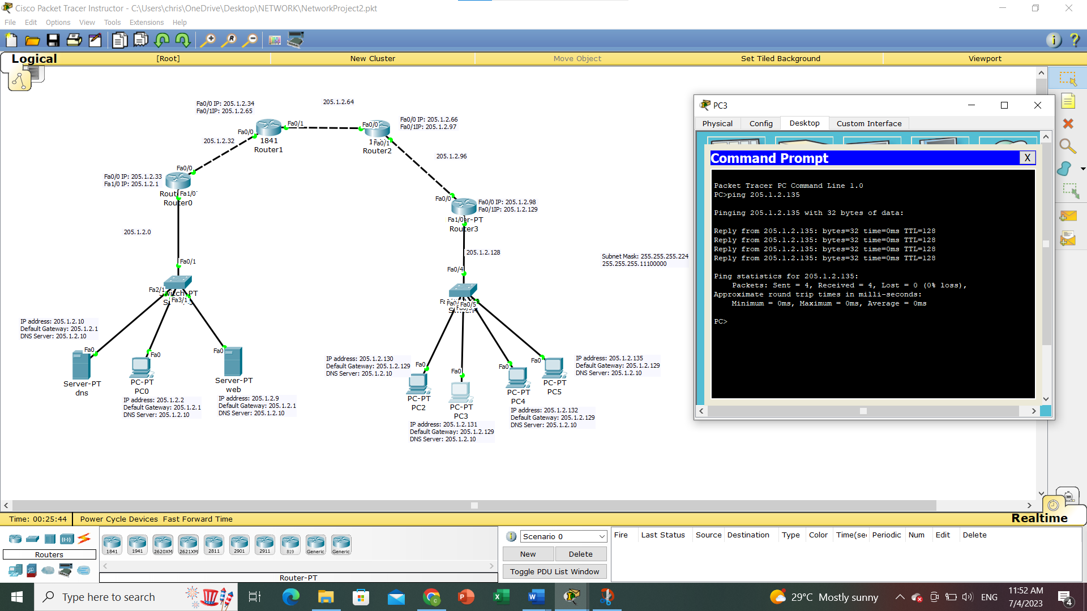

### Use tracert command to show the path a packet traversed to reach its destination from each subnet host to a remote destination.

The below figure shows the tracert used to track the routers traveled from PC0 to PC3 in the command prompet.

It traveled through router0 205.1.2.1 to router1 205.1.2.34 to router2 205.1.2.66 to router3 205.1.2.98 to PC3 205.1.2.131

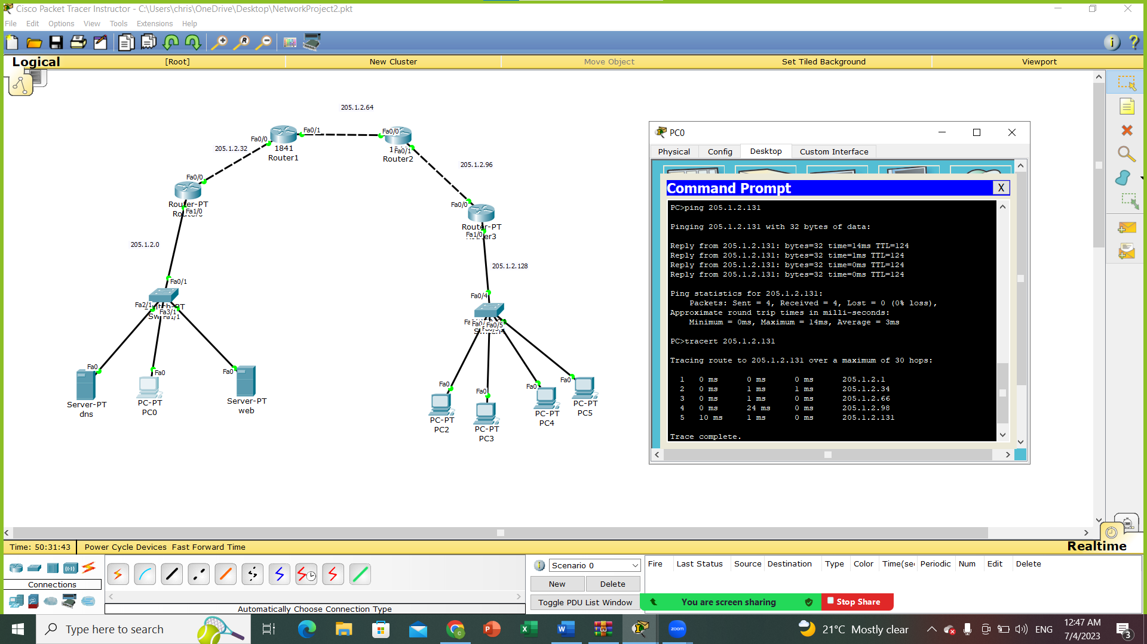

The below figure shows the tracert used to track the routers traveled from PC3 to PC0 in the command prompet.

It traveled through router3 205.1.2.129 to router2 205.1.2.97 to router1 205.1.2.65 to router0 205.1.2.33 to PC0 205.1.2.2

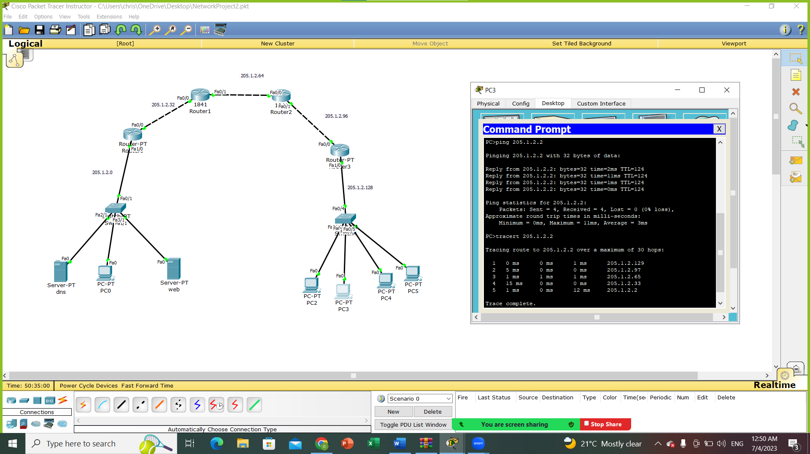

### Use dns server and web server

The figure below shows how PC3 is connect to [www.myweb.com](http://www.myweb.com) in which the message we wrote showed (“Welcome to ENCS3320 second project. The partners are (Jenin, Christina, Pierre)”).

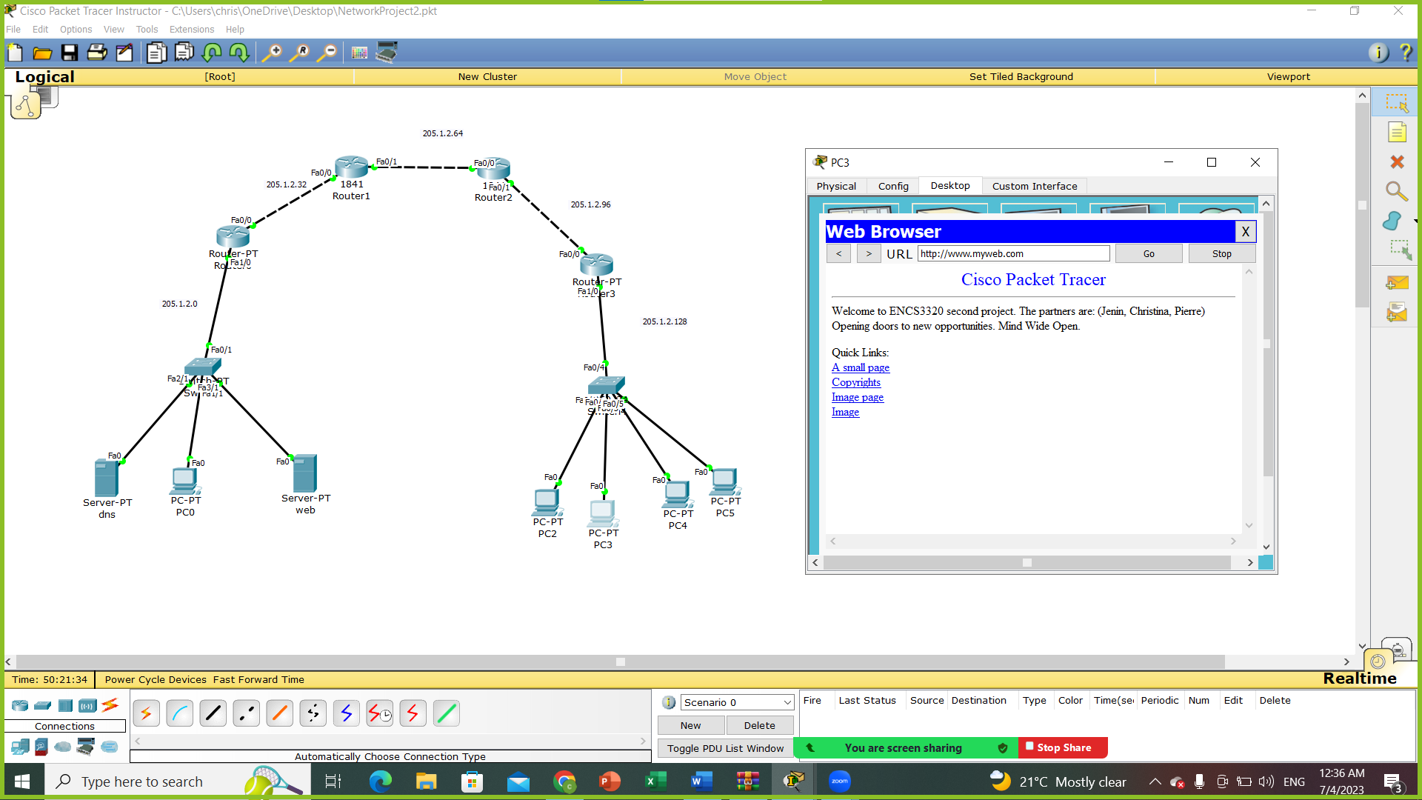

The figure below shows how PC0 is connect to [www.myweb.com](http://www.myweb.com) in which the message we wrote showed (“Welcome to ENCS3320 second project. The partners are (Jenin, Christina, Pierre)”).

